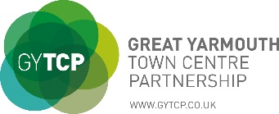
2022 CARNIVAL DOLL TRAIL
Find the Circus Dolls displayed in participating locations and then fill out the form below by correctly adding the corresponding numbers next to the venue name. Once completed the form can be left at any one of the stores included on the trail for your chance to win a prize!
Name: Email Address:
Postcode: Contact No.
Shop/Venue | Address | Doll number
Unique Crafts | Market Row
Norman Antiques | Market Row
Belzart | Market Row
Noble Crafts | Market Row
Poundland | Market Place
Hair Chair | Market Row
Norman & Sons | Market Place
Poundstretcher | Fullers Hill
Kirsty’s Cakery | The Old Vicarage
Peacocks | Market Place
Trespass | Market Gates
Blue Inc | Market Gates
Select | Market Gates
Claire’s | Market Gates
F Hinds | Market Gates
Shoe Zone | Market Gates
Wilko | Market Gates
YMCA Charity Shop | Market Gates
Louise Hamilton Trust | Theatre Plain
Clarks | King Street
Poundstretcher | Regent Road
St. Georges Café | King Street
Harbour Radio | King Street
Great Yarmouth Library | Yarmouth Way
DIAL | King Street
Salvation Army Shop | King Street
Toy Box | Victoria Arcade
Kierrans Home Store | King Street
Mocha Coffee Lounge | Regent Street
CEX | King Street
WH Smith | King Street

